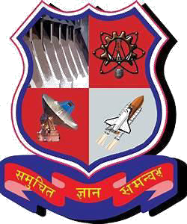

###### Dr Jivraj Mehta Institute of technology, (Mogar)

A report on

###### Web Based Bus Reservation System

Under subject of

###### DESIGN ENGINEERING -1A

B.E.-Semester-3 (Computer Branch)

|  |  |  |  |
| --- | --- | --- | --- |
|  | | Submitted by |  |
| Sr. | Name Of Student |  | Enrollment No. |
| 1 | Chavda Tirthak Y |  | 190820107003 |
| 2 | Patel Dhruv M |  | 190820107015 |
| 3 | Rajput Brijesh K |  | 190820107025 |
| 4 | Vaghela Vishwadeep V |  | 190820107030 |

###### Mrs. Parmar Mamtaben J

(Faculty Guide) Academic Year (2020-2021)

Page **1** of **28**

###### Dr. Jivraj Institute of Technology, (Mogar)



**CERTIFICATE**

This is to certify that the Design Engineering canvases entitled “**WEB BASED BUS RESERVATION SYSTEM”** has been carried out by **Chavda Tirthak (190820107003), Patel Dhruv (190820107015), Rajput Brijesh (190820107025), Vaghela Vishwadeep (190820107030)** of Degree Computer Engineering Department have successfully completed their case study report.

DATE: - _

**Mrs. Parmar Mamtaben J Prof. Bhupendra Patel**

INTERNAL FACULTY HEAD OF DEPARTMENT

Page **2** of **28**

**Sr.No**

###### Title

**Page No.**

**1**

Introduction

* What is Design of Engineering?
* Why we need online reservation system?

5

**5**

Ideation Canvas

17

* People
* Activities
* Situations / context / location
* Props / tools / objects / equipment

**2** AEIOU Canvas 6

* Activities
* Environment
* Interaction
* Object
* Users

**3** Mind Mapping Canvas 12

**4** Empathy Canvas 13

* Users
* Stack holders
* Activities
* Story Boarding

**6** Product Development Canvas 21

* Purpose
* Product Experience
* Product Function
* People
* Product Features
* Components
* Customer Revalidation
* Reject, Redesign, Retain

* How Flow chart works??

**7**

Prototype

27

#### INTRODUCTION

* **What is Design of engineering?**

A design of engineer is a person who may be involved in any of various engineering disciplines including civil, mechanical, electrical, computer etc,. Design of engineering is very unique subject of GTU (Gujarat Technical University). It is very useful for us in every field. By this particular subject we can get very much experience for team works and team handling. In this subject we also learn how we can research in particular subject and how we found information by our research.

#### Why we need online bus reservation?

* If people have less time for booking ticket.
* If people don’t want to stay in long queue.
* If people are tired of misbehave at the depot.
* If people are tired of problem of change.

# AEIOU CANVAS

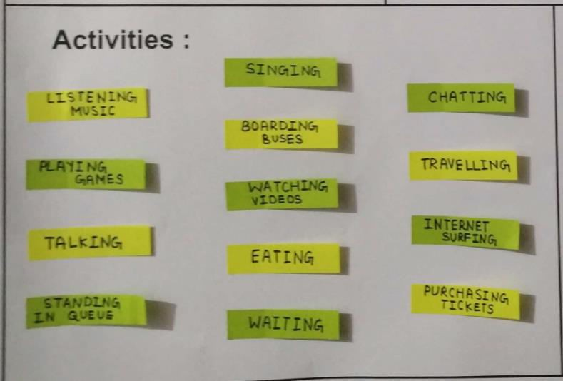

##### What is AEIOU CANVAS?

**AEIOU** is an investigative tool to help interpret observations gathered by ethnographic practices in the field. It is an Observation tool. Its two primary functions are to code data, and to develop building blocks of models that will ultimately address the objectives and issues of a client.

##### Activities:-

|  |  |  |
| --- | --- | --- |
| 1) Listening Music | 5) Standing Queue | 9)Chatting |
| 2) Playing Games | 6) Singing | 10)Travelling |
| 3)Talking | 7) Boarding Buses | 11)Internet Surfing |
| 4)Watching Videos | 8)Waiting | 12)Eating |

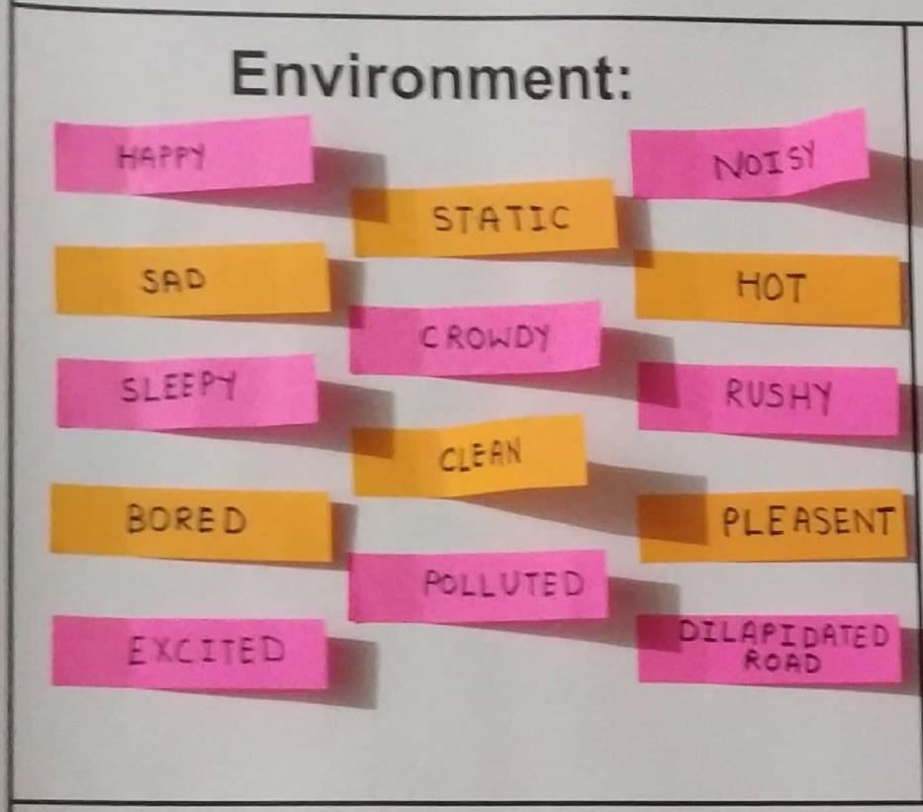

1. **Environment: -**

|  |  |  |
| --- | --- | --- |
| 1) Happy | 6) Static | 11) Hot |
| 2) Sad | 7) Crowdy | 12) Rushy |
| 3) Sleepy | 8) Clean | 13) Pleasant |
| 1. Bored 2. Excited | 1. Polluted 2. Noisy | 14) Dilapidated Road |

##### Interaction : -

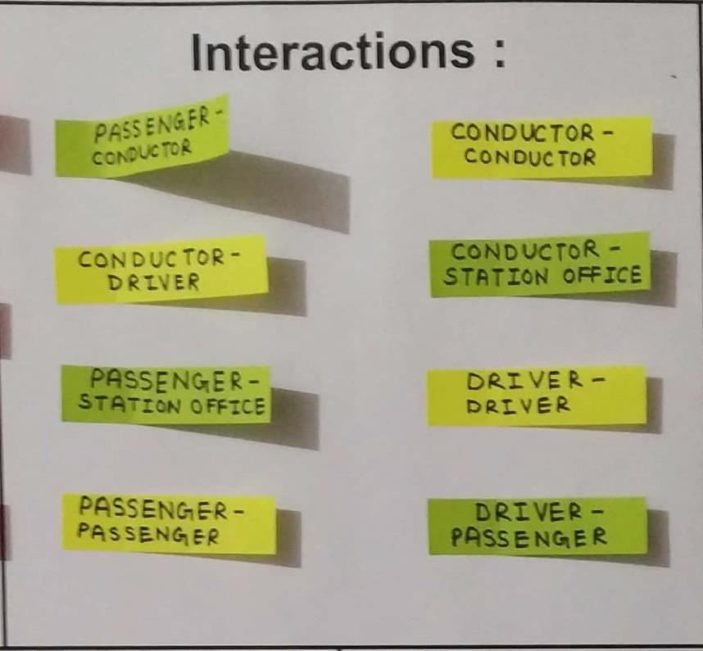

1. Passenger to Conductor 5) Conductor to Conductor
2. Conductor to Driver 6) Conductor to Station Office
3. Passenger to Station Office 7) Driver to Driver
4. Passenger to Passenger 8) Driver to Passenger

##### Objects : -

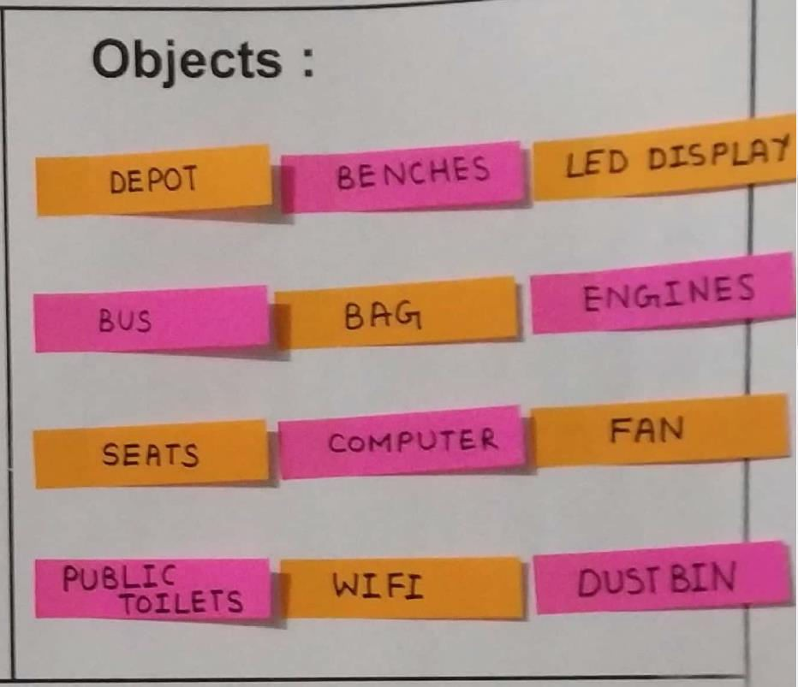

|  |  |
| --- | --- |
| 1) Depot | 7) Computer |
| 2) Bus | 8) Engines |
| 3) Seats | 9) Fan |
| 4) Public Toilets | 10) Dustbin |
| 5) Benches | 11) Wi-Fi |
| 6) Bag | 12) LED Display |

* 1. **User : -**

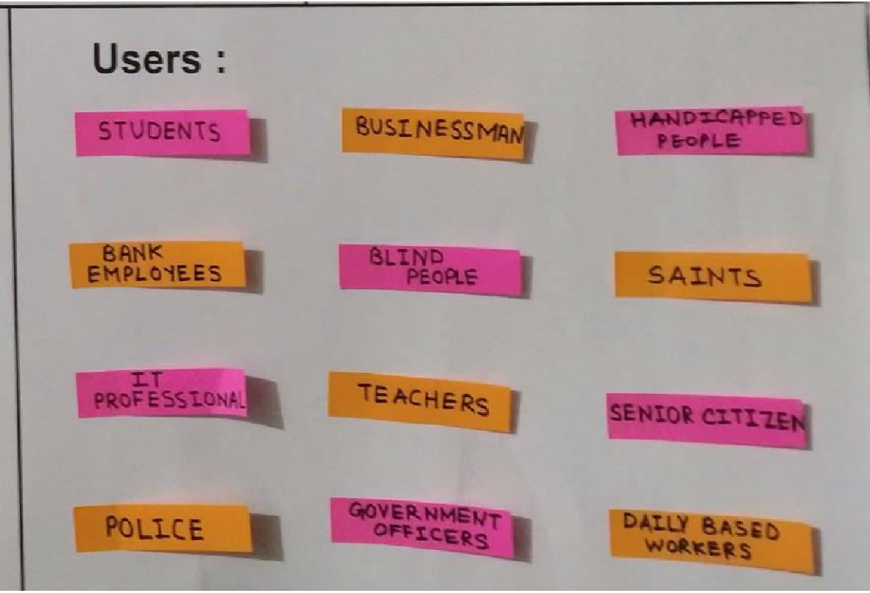

1. Student 7) Teachers
2. Bank Employees 8) Government Officers
3. IT Professional 9) Handicapped People
4. Police 10) Saints
5. Businessman 11) Senior Citizen
6. Blind People 12) Daily Based Workers

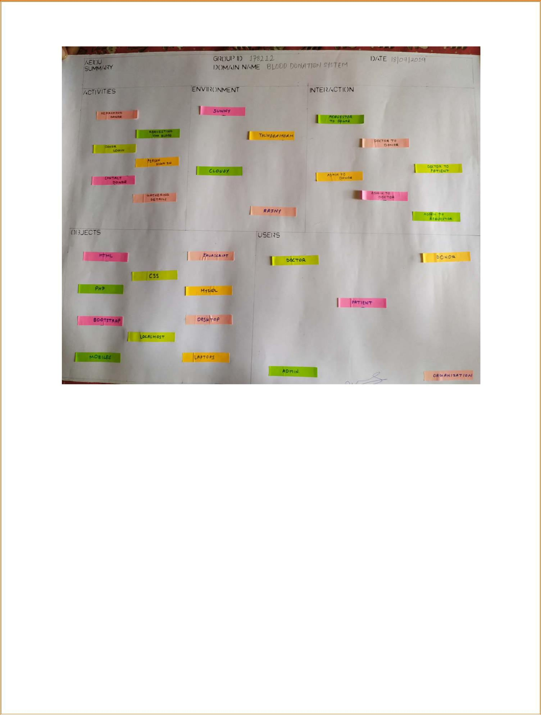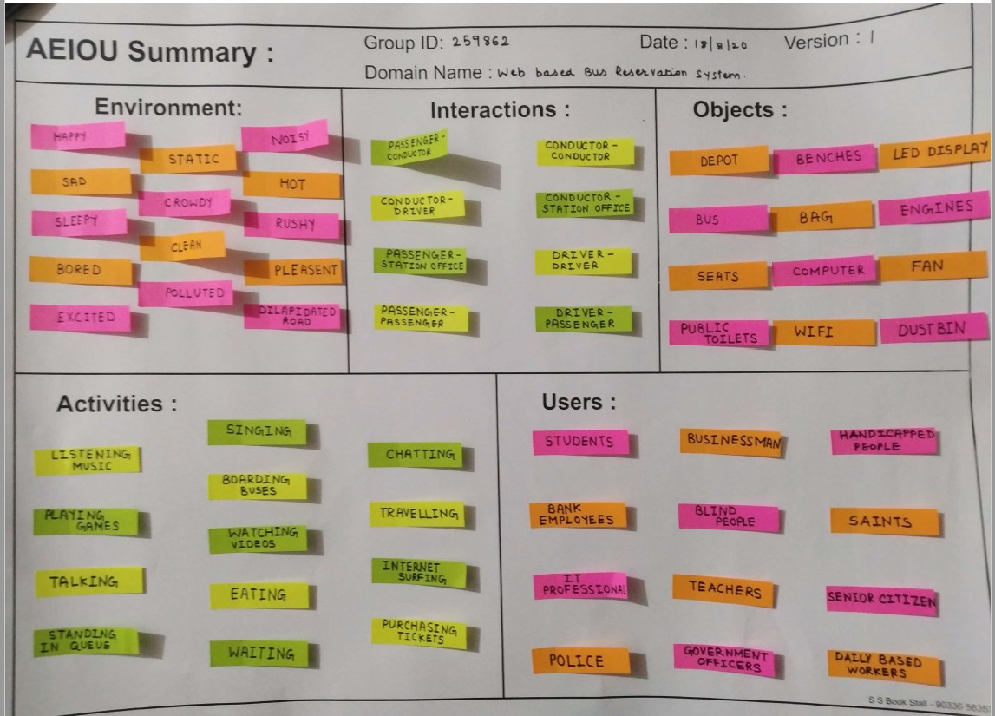

Page **11** of **28**

# Mind Mapping

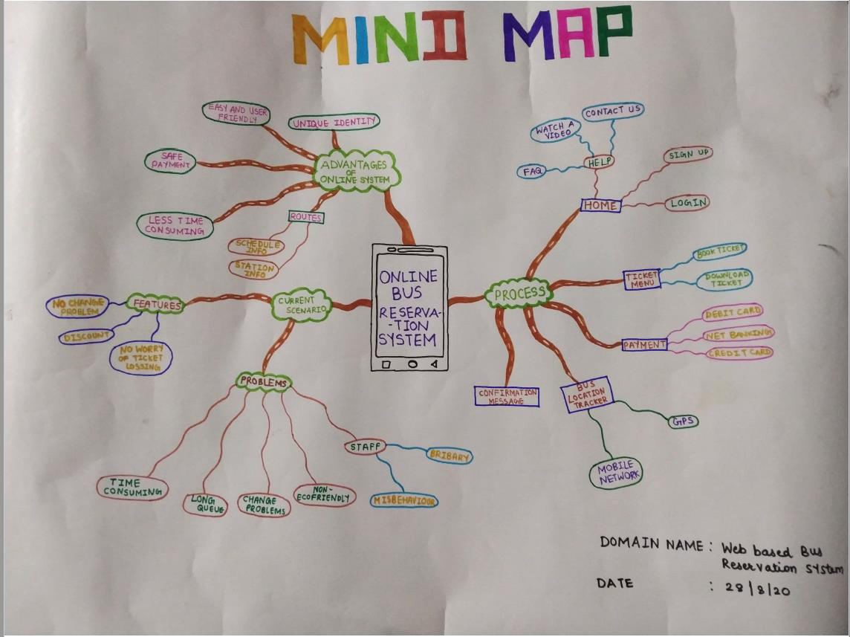

Mind mapping is technique to develop thinking approach of a person observing over project thinking more and better over their subject. A mind map is a graphical way to represent ideas and concepts. It is a visual thinking tool that helps structuring information, helping you to better analyse, comprehend, synthesize, recall and generate new ideas.

Just as in every great idea, its power lies in its simple. There are main users and stakeholders

Main users: Student, Teacher, Bank Employees, Businessman Stakeholders: Network Administration, Software Developer, etc

# Empathy Canvas

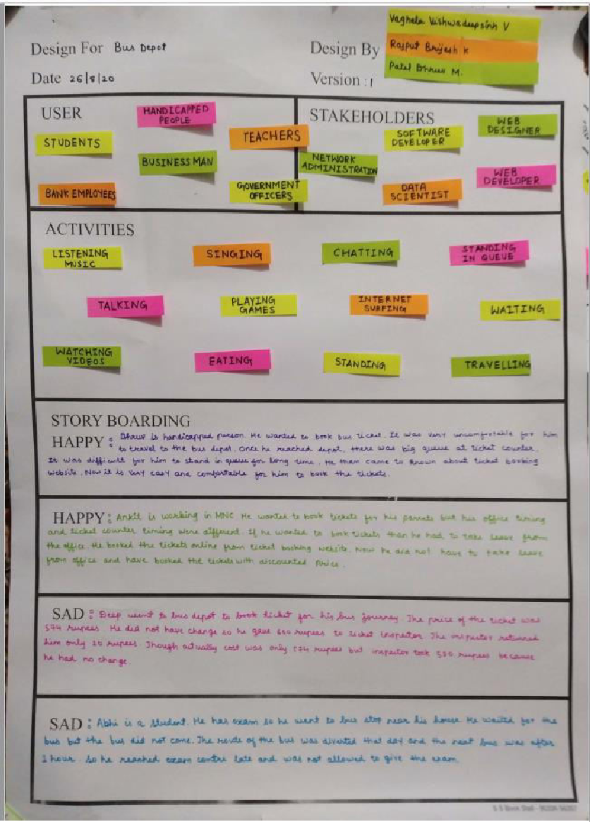

### What is Empathy canvas?

**Empathy** Mapping is a tool that a learner can use to gain a depth of insight into the emotions of a user of their choice. It helps in identifying specific act by the user in a given circumstances or conditions. Through imaginations, a learner learns to create or visualize scenarios using one's thoughts.

* 1. **Users:-**

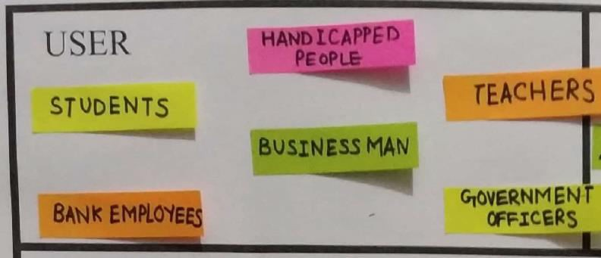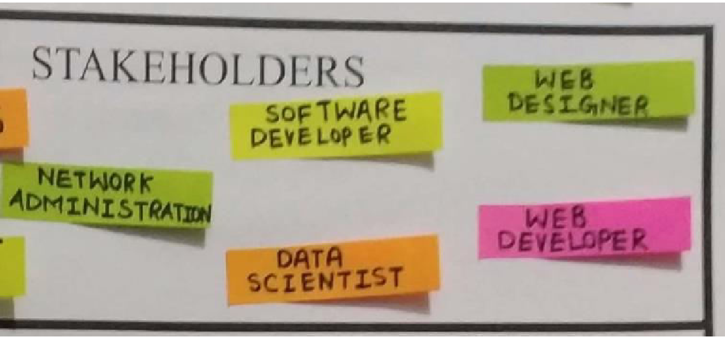

|  |  |  |
| --- | --- | --- |
| 1) Student | 3) Handicapped People | 5) Teachers |
| 2) Bank Employee  **2) Stakeholders : -** | 4) Government Officers | 6) Businessman |

1. Network Administration 3) Data Scientist
2. Software Developer 4) Web Designer
3. **Activities:-**

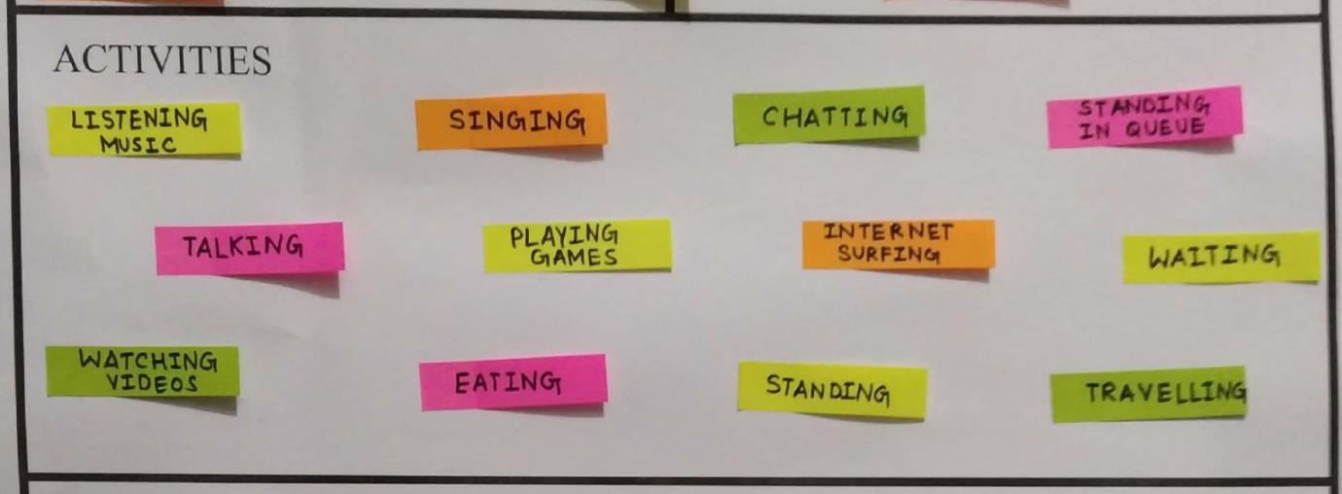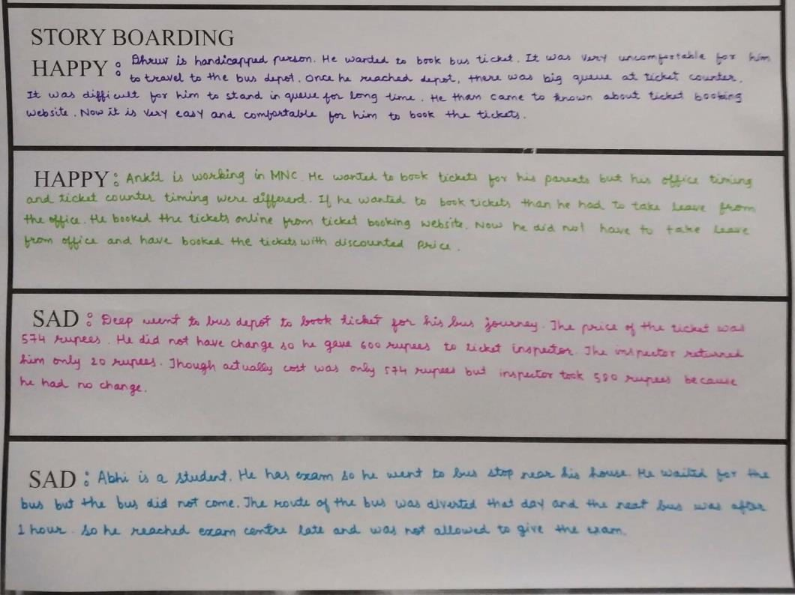

1. Listening Music 4) Singing
2. Internet Surfing 5) Playing Games
3. Watching Videos 6) Travelling

#### Story Boarding: -

**Happy: -**

Dhruv is handicapped person. He worked to book bus ticket. It was very uncomfortable for him to travel to the bus depot. Once he reached depot, there was big queue at ticket counter. It was difficult for him to stand in queue for long time. He then came to know about ticket booking website. Now it is very easy and comfortable for him to book the tickets.

#### Happy: -

Ankit is working in MNC. He wanted to book tickets for his parents but his office timing and ticket counter timing were different. If he wanted to book tickets than he had to take leave from the office. He booked the tickets online from ticket booking website. Now he did not have to take leave from office and have booked the tickets with discounted price.

#### Sad: -

Deep went to bus depot to book ticket for his bus journey. The price of the ticket was 574 rupees. He did not have change so he gave 600 rupees to ticket inspector. The inspector returned him only 20 rupees. Though actually cost was only 574 rupees but inspector took 580 rupees because he had no change.

#### Sad: -

Abhi is a student. He has exam so he went to bus stop near his house. He waited for the bus but the bus did not come. The route of the bus was diverted that day and the next bus was after 1 hour so he reached exam centre late and was not allowed to give the exam.

**IDEATION CANVAS**

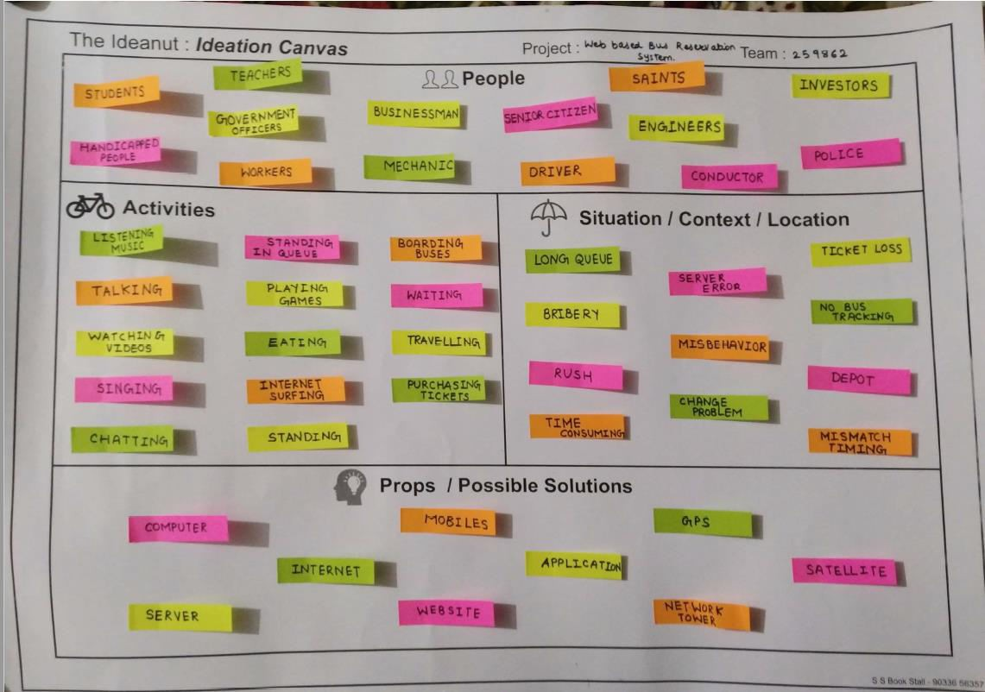

### What is Ideation Canvas ?

Ideation is the creative process of generating, developing, and communicating new ideas, where an idea is understood as basic element of thought that can be either visual or concrete or abstract.

Ideation comprises all stages of a through cycle, from innovation, to development, to actualization.

This is the structure of Ideation Canvas.

This is the picture of the canvas which is created by us.

As you can see that in particular image there are four partitions are there: -

#### 1) People: -

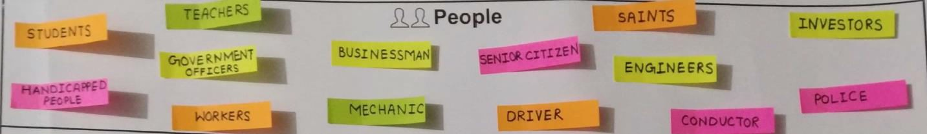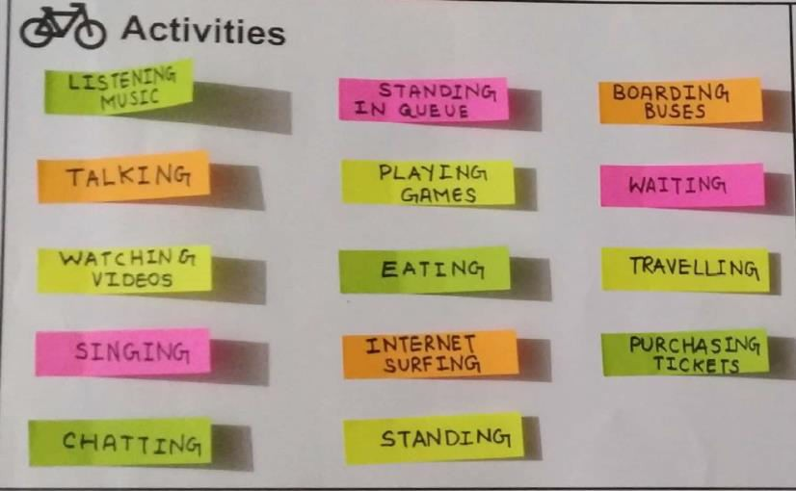

The following are some people which are included in our ideation canvas: -

1. Mechanic 5) Driver
2. Engineers 6) Workers
3. Conductor 7) Businessman
4. Teachers 8) Students

#### 2) Activities: -

1. Eating 4) Singing
2. Internet Surfing 5) Travelling
3. Playing Games 6) Talking

#### 3) Situations/ Context/ Location : -

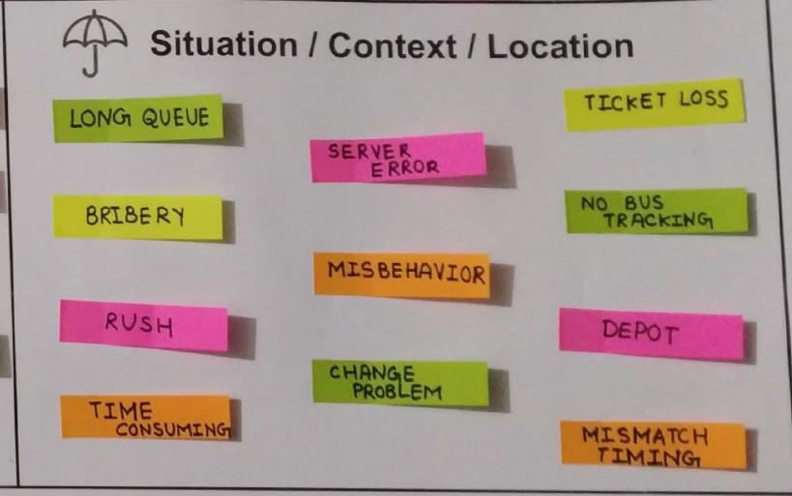

In this point we have define the situation in what the people are there in bus depot. The problem the people face without using online bus service.

1. Long Queue 6) Ticket Loss
2. Bribery 7) No Bus Tracking
3. Rush 8) Server Error
4. Time Consuming 9) Change Problem
5. Misbehaviour 10) Mismatch Timing

#### 4) Props/ Tools/ Objects/ Equipment :-

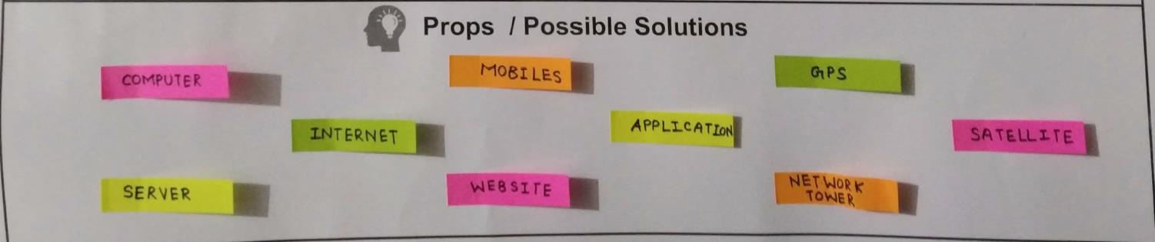

1. Computer
2. Server
3. Internet
4. Website
5. Mobiles
6. Application
7. GPS
8. Network Tower
9. Satellite
10. Laptop

## PRODUCT DEVELOPMENT CANVAS

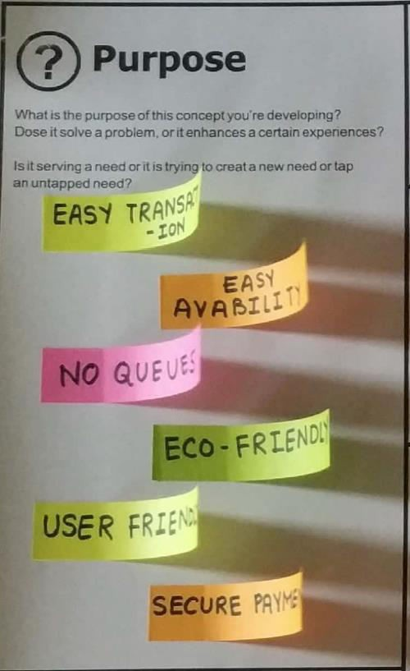

###### What is Product Development Canvas?

➔ The Product Development Canvas is for product strategy on one page. This canvas used by thousands of product managers across hundreds of companies, the Product Canvas is a strategic planning tool allows product managers to map, design, describe and differentiate their product strategy on a single page.

* 1. **Purpose : -**
     + Easy transaction
     + Easy availability of ticket
     + No queues
     + Eco – Friendly and User - Friendly
     + Secure Payments
  2. **Product Experience : -**

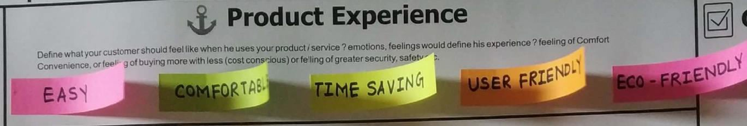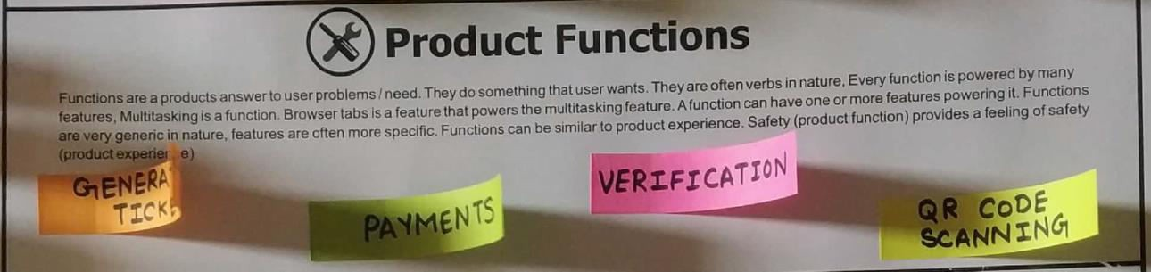

* + - Easy and Comfortable
    - Time Saving
    - User - Friendly
    - Eco - Friendly

##### Product Function : -

* + Generating Ticket
  + Payments
  + Verification
  + QR Code Scanning

##### People : -

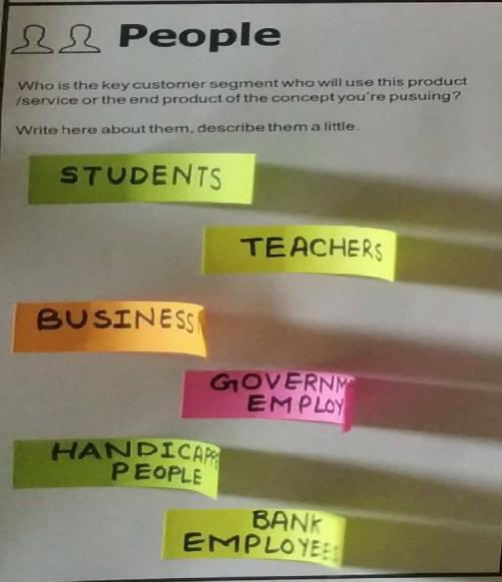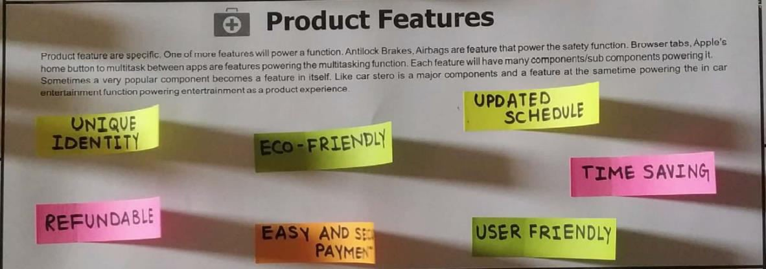

* + - Students
    - Teachers
    - Businessman
    - Government Employee
    - Handicapped People

##### Product Features : -

* + - Unique Identity
    - Payment Refundable
    - Easy and Secure Payment
    - Updated Schedule
    - User - Friendly and Eco - Friendly

Page **23** of **28**

##### Components : -

⇒Internet

⇒Server

⇒Visual Studio

⇒Website

⇒My SQL

⇒Application

⇒Computer and Mobile ⇒Android Studio

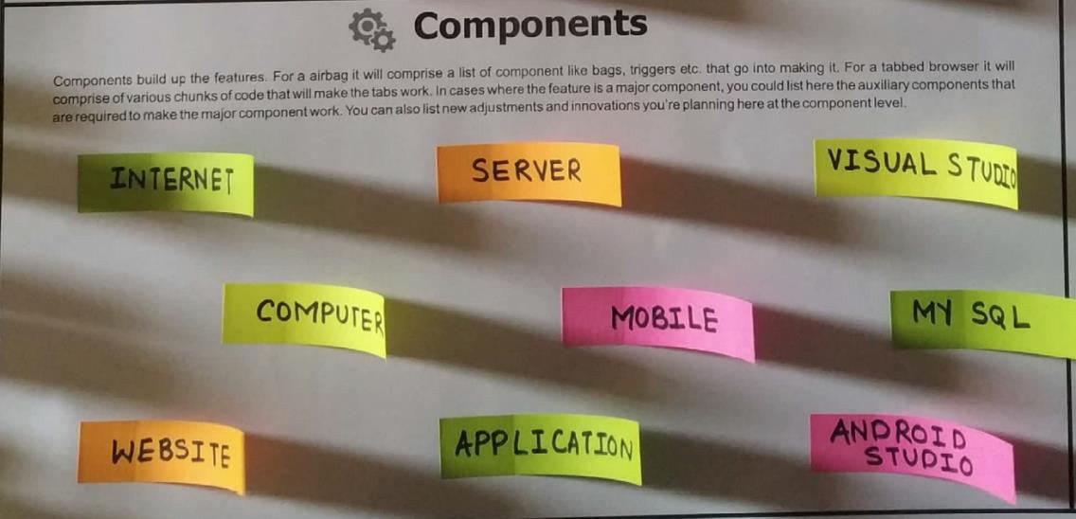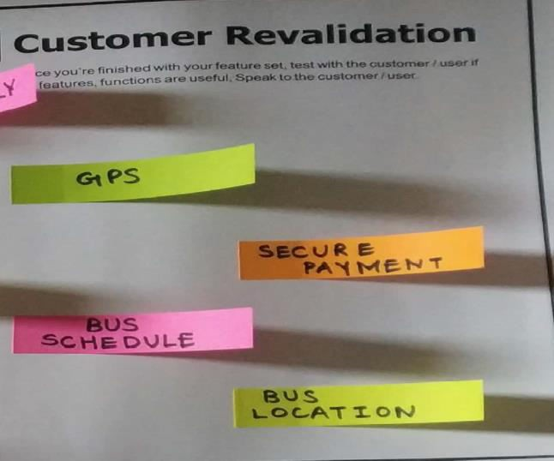

##### Customer Revalidation : -

* + - Fear of insecure payment
    - Inadequate bus schedule and bus location
  1. **Reject, Redesign, Retain : -**
     + Online transaction ⇒

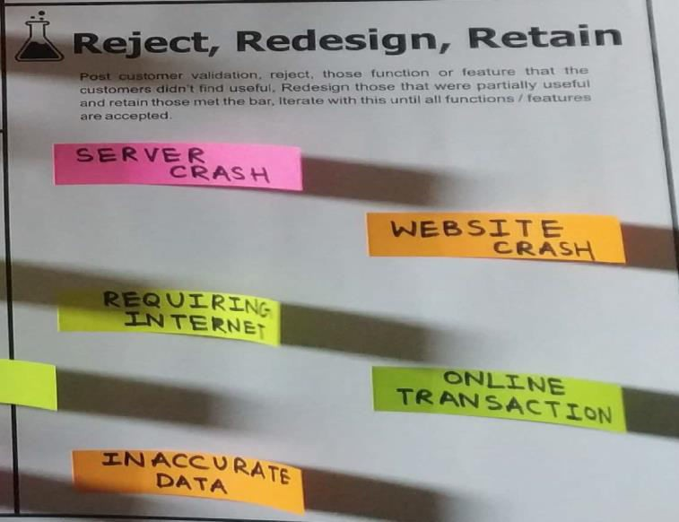

* + - Inaccurate data ⇒

Server & Website crash Requirement of Internet

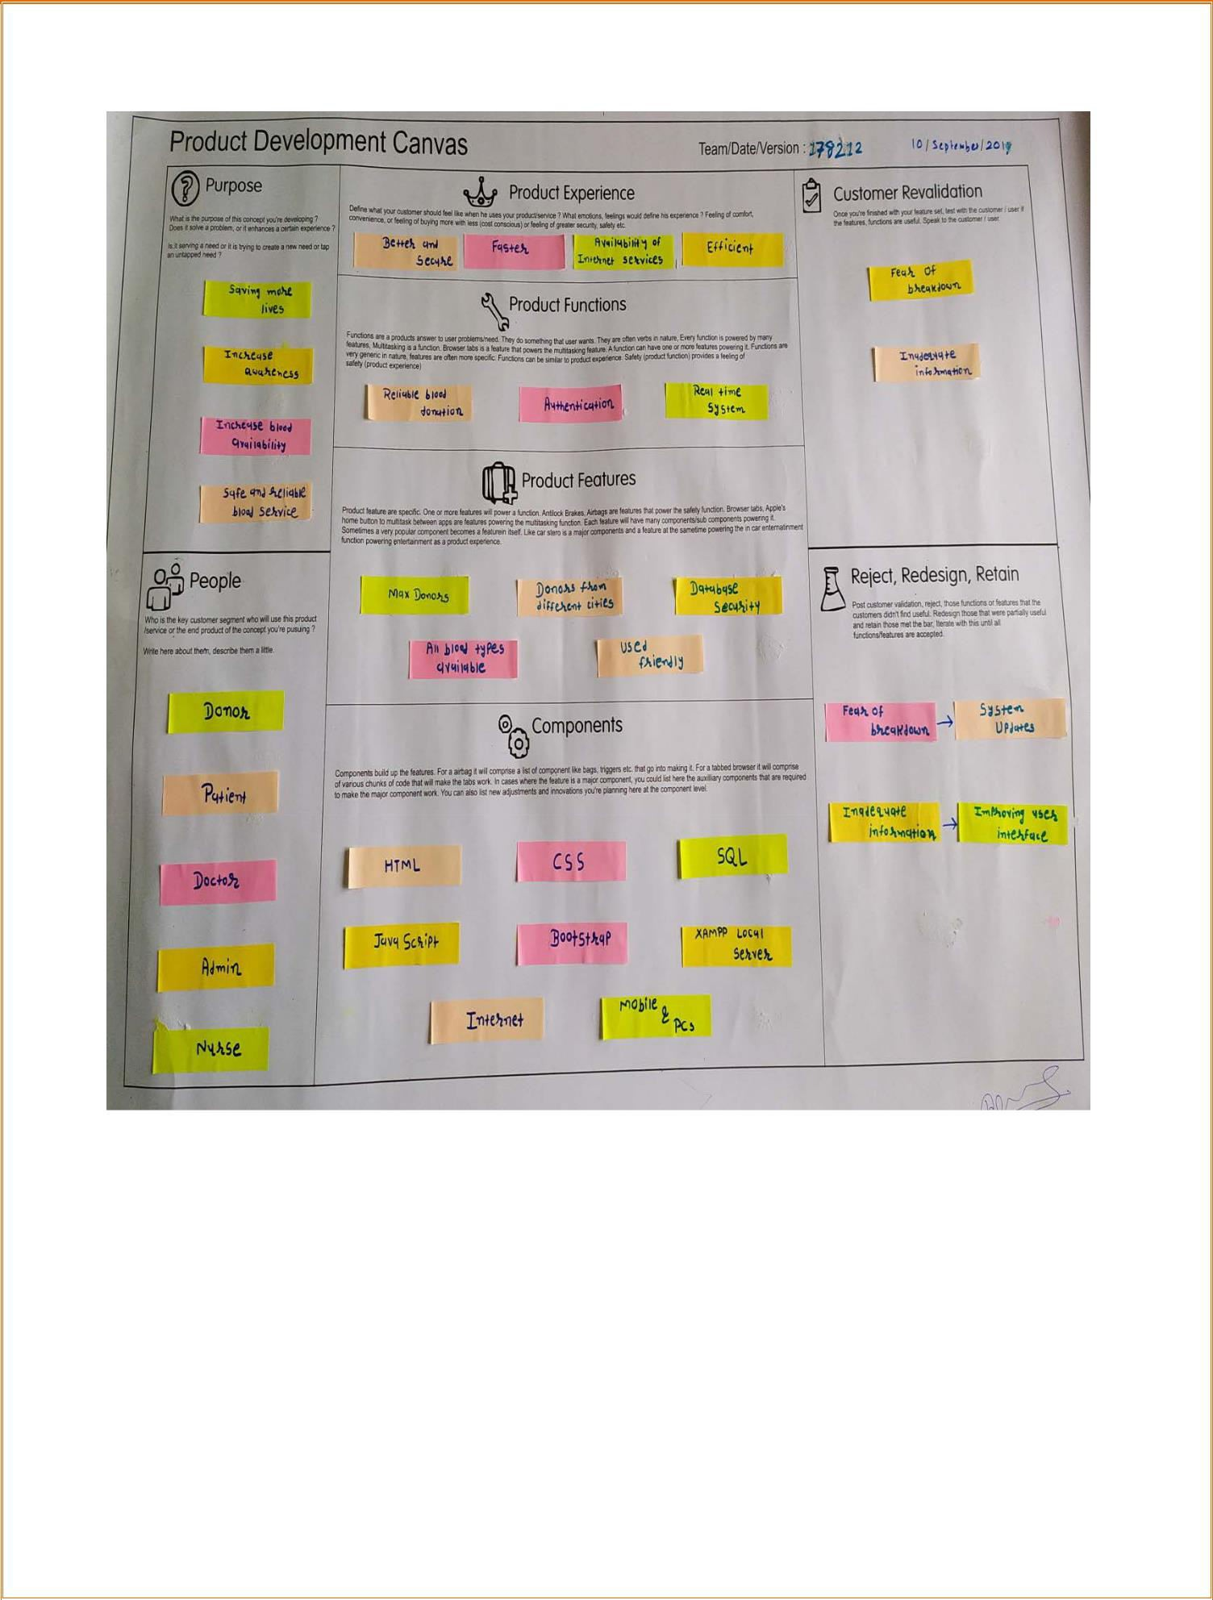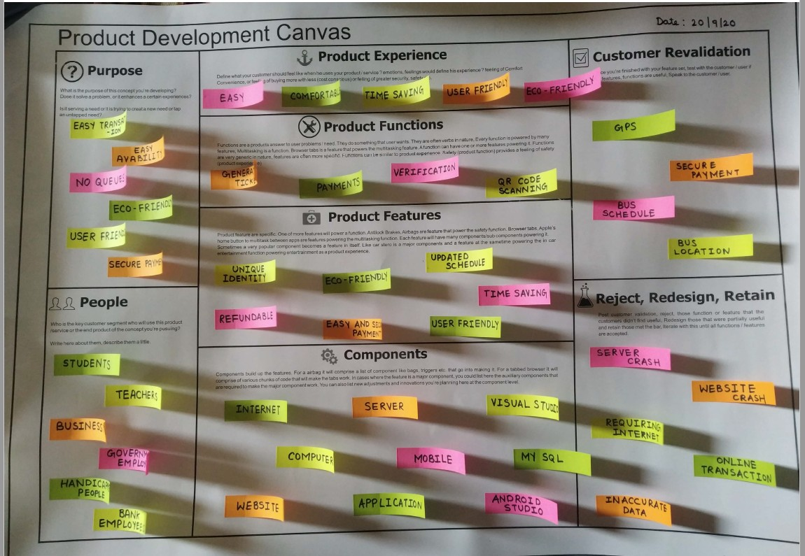

Page **26** of **28**

**Flow Chart**

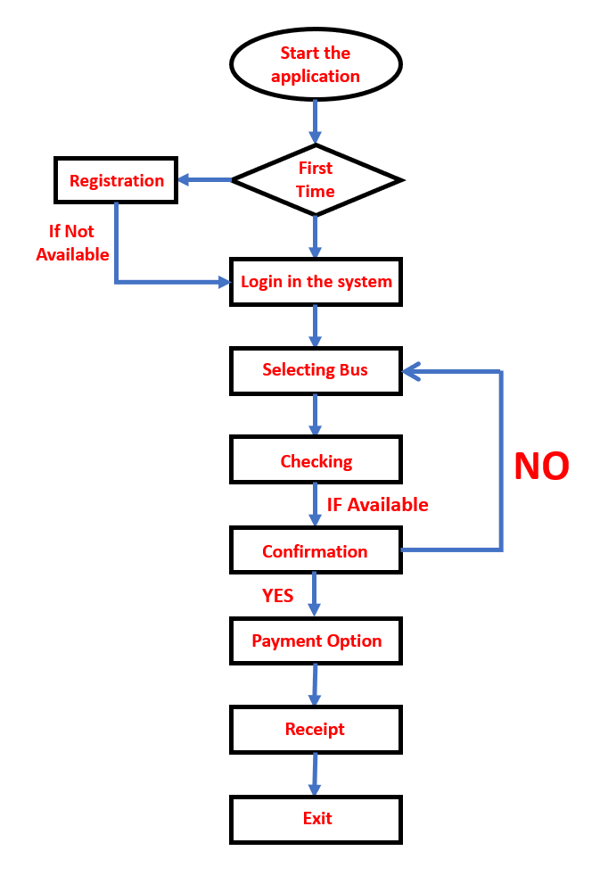

**How Flowchart Works?**

* + Whenever any user wants to book bus ticket, he has to log in and if he doesn’t have an account than have to register.
  + After registration if user want to book a bus than he needs to select the bus and if the bus seat is available than the user needs to confirm if he wants to book the ticket.
  + After confirming the ticket user need to choose the payment method he wants to pay for the tickets.
  + After paying for tickets user will receive receipt of payment and will receive e-ticket which he needs to show in his bus journey to conductor.
  + In this way our project of Web based Bus Reservation System works.